

**CSE488: Big Data Analytics**

**[SPRING 2023]**

**Lab-5**

**MapReduce to Itemset Count**

**Submitted by:**

Student ID: 2019-3-60-046

Student Name: Mohsenul Kabir Mithun

**Creating a Hadoop project in Eclipse: (MapReduce used for ItemsetCount)**

Source Code SS: (Mapper and Reducer Class)

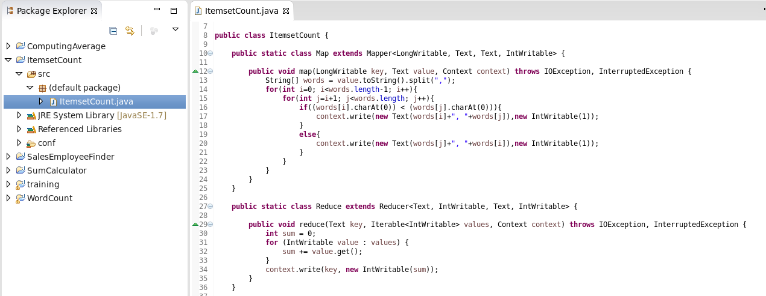

Creating Jar file:

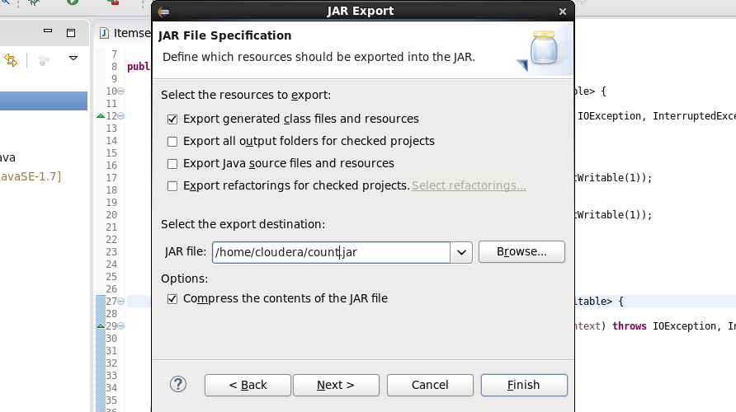

Creating Input file:

CMD run the program:

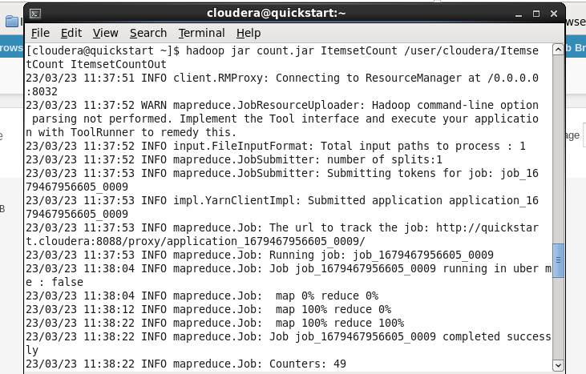

OutPut:

